 | 26.10.9 Editors - Properties Editor - Particle Properties Tab - Emitter - Children panel
Table of content
Detailed table of content 2
Children panel 5
Children panel - Type None 5
Child Type 5
Children panel - Type Simple 5
Children panel - Type Simple - Clumping subpanel 6
Use Clump Curve 6
Clump 8
Shape 8
Twist 8
Use Clump Curve 8
Children panel - Type Simple - Clump Noise subpanel 9
Clump Noise subpanel 9
Children panel - Type Simple - Roughness subpanel 9
Use Roughness Curve 10
Roughness 11
Size 11
Uniform 11
Size 11
Endpoint 11
Shape 12
Random 12
Size 12
Threshold 12
Children panel - Type Simple + Interpolated - Kink subpanel 12
Kink Type 12
Children panel - Type Interpolated 14
Display Amount 14
Render Amount 14
Length 14
Threshold 14
Seed 14
Virtual Parents 14
Long Hair 14
Children panel - Type Interpolated - Parting subpanel 14
Parting 14
Min 15
Max 15
Children panel - Type Interpolated - Clumping subpanel 15
Use Clump Curve 15
Clump 16
Shape 16
Clump Noise subpanel 17

Detailed table of content
Detailed table of content
Detailed table of content 2
Children panel 5
Children panel - Type None 5
Child Type 5
None 5
Children panel - Type Simple 5
Simple 5
Display Amount 5
Render Amount 5
Length 5
Threshold 5
Seed 5
Size 5
Random Size 6
Radius 6
Roundness 6
Children panel - Type Simple - Clumping subpanel 6
Use Clump Curve 6
Adding Points 6
Selecting Points 6
Navigation elements 6
Zoom in and out 6
Clipping 7
Delete Points 7
Tools 7
Reset View 7
Extend horizontal 7
Extend vertical 7
Reset Curve 7
Vector Handle 7
Auto Handle 7
Auto Clamped Handle 7
X / Y values 7
Delete Points 7
Twist 7
Clump 8
Shape 8
Twist 8
Use Clump Curve 8
Adding Points 8
Selecting Points 8
Navigation elements 8
Zoom in and out 8
Clipping 8
Delete Points 8
Tools 9
Reset View 9
Extend horizontal 9
Extend vertical 9
Reset Curve 9
Vector Handle 9
Auto Handle 9
Auto Clamped Handle 9
X / Y values 9
Delete Points 9
Children panel - Type Simple - Clump Noise subpanel 9
Clump Noise subpanel 9
Clump Noise Size 9
Children panel - Type Simple - Roughness subpanel 9
Use Roughness Curve 10
Adding Points 10
Selecting Points 10
Navigation elements 10
Zoom in and out 10
Clipping 10
Delete Points 10
Tools 10
Reset View 10
Extend horizontal 11
Extend vertical 11
Reset Curve 11
Vector Handle 11
Auto Handle 11
Auto Clamped Handle 11
X / Y values 11
Delete Points 11
Roughness 11
Size 11
Uniform 11
Size 11
Endpoint 11
Shape 12
Random 12
Size 12
Threshold 12
Children panel - Type Simple + Interpolated - Kink subpanel 12
Kink Type 12
Nothing 12
Curl, Radial, Wave, Braid 12
Amplitude 12
Clump 13
Flatness 13
Frequency 13
Shape 13
Spiral 13
Amplitude 13
Randomize Amplitude 13
Axis 13
Randomize Axis 13
Frequency 13
Shape 13
Steps 13
Children panel - Type Interpolated 14
Display Amount 14
Render Amount 14
Length 14
Threshold 14
Seed 14
Virtual Parents 14
Long Hair 14
Children panel - Type Interpolated - Parting subpanel 14
Parting 14
Min 15
Max 15
Children panel - Type Interpolated - Clumping subpanel 15
Use Clump Curve 15
Adding Points 15
Selecting Points 15
Navigation elements 15
Zoom in and out 15
Clipping 15
Delete Points 16
Tools 16
Reset View 16
Extend horizontal 16
Extend vertical 16
Reset Curve 16
Vector Handle 16
Auto Handle 16
Auto Clamped Handle 16
X / Y values 16
Delete Points 16
Clump 16
Shape 16
Clump Noise subpanel 17
Clump Noise Size 17

Children panel
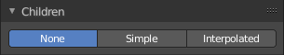
Children are Hair or Emitter particles originating from individual particles. They allow to work with a relatively low amount of Parent particles. Which reduces the calculation effort.
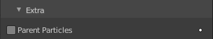
If you activate children, then the parents are no longer rendered. They can be re-enabled in the Render panel in the Extras subpanel. Parent Particles. By default, parent particles are not rendered because the shape of the children can be quite different from that of their parents.

Children panel - Type None

Child Type

None
No children are generated. No settings.

Children panel - Type Simple

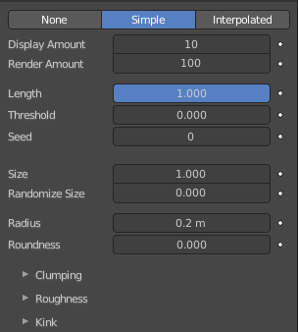
Simple
Children are emitted from the parent position.

Display Amount
The number of children in the 3D Viewport.

Render Amount
The number of children to be rendered.

Length
Length of child paths.

Threshold
Amount of particles left untouched by child path length.

Seed
Offset in the random number table for child particles, to get a different randomized result.

Size
A multiplier for children size.

Random Size
Random variation to the size of child particles

Radius
The radius in which the children are distributed around their parents. This is 3D, so children may be emitted higher or lower than their parents.

Roundness
The roundness of the children around their parents. Either in a sphere (1.0) or in-plane (0.0).

Children panel - Type Simple - Clumping subpanel
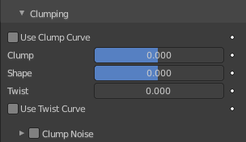
Clumping allows as the name says to break the even look, and clump particles together.

Use Clump Curve
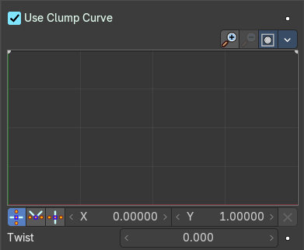
Use a Curve instead of parameters to adjust the clumping.

Adding Points
You can add new curve points by simply left clicking at the curve. Move the mouse to position them where you need it.

Selecting Points
You can select curve points by clicking at them.
Selected points can be moved around. Left click at them, hold the mouse button down and move them to a new location.

Navigation elements
The navigation elements at the top are described from left to right.

Zoom in and out
The two buttons with the magnifying glass at it zooms in and out in the curve window.

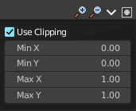
Clipping
Clipping options. Set up clipping for the stroke.

Delete Points
Deletes selected curve points.

Tools
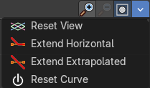
Tools is a menu where you can find some curve related tools.

Reset View
Resets the curve windows zoom.

Extend horizontal
Extend the curve horizontally before the first and after the last curve point.

Extend vertical
Extend the curve vertically before the first and after the last curve point.

Reset Curve
Resets the curve to the initial shape.

Vector Handle
Set handle type to Vector.

Auto Handle
Set handle type to Auto.

Auto Clamped Handle
Set handle type to Auto Clamped.

X / Y values
The x and y position of the current selected curve point.

Delete Points
Delete the current selected curve point.

Twist
Number of turns around parent along the strand.

Clump
Clumping amount along child strands. The children may meet at their tip (1.0) or start together at their root (-1.0).

Shape
Form of Clump. Either inverse parabolic (0.99) or exponentially (-0.99).

Twist
Number of turn around parent along the strand.

Use Clump Curve
Use a Curve instead of parameters to adjust the clumping.

Adding Points
You can add new curve points by simply left clicking at the curve. Move the mouse to position them where you need it.

Selecting Points
You can select curve points by clicking at them.
Selected points can be moved around. Left click at them, hold the mouse button down and move them to a new location.

Navigation elements
The navigation elements at the top are described from left to right.

Zoom in and out
The two buttons with the magnifying glass at it zooms in and out in the curve window.

Clipping
Clipping options. Set up clipping for the stroke.

Delete Points
Deletes selected curve points.

Tools
Tools is a menu where you can find some curve related tools.

Reset View
Resets the curve windows zoom.

Extend horizontal
Extend the curve horizontally before the first and after the last curve point.

Extend vertical
Extend the curve vertically before the first and after the last curve point.

Reset Curve
Resets the curve to the initial shape.

Vector Handle
Set handle type to Vector.

Auto Handle
Set handle type to Auto.

Auto Clamped Handle
Set handle type to Auto Clamped.

X / Y values
The x and y position of the current selected curve point.

Delete Points
Delete the current selected curve point.

Children panel - Type Simple - Clump Noise subpanel

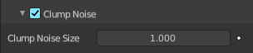
Clump Noise subpanel
Creates random clumps around the parent hair.

Clump Noise Size
The size of clump noise.

Children panel - Type Simple - Roughness subpanel

Give the particles a roughness.

Use Roughness Curve
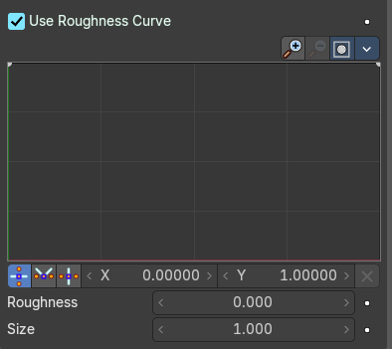
Use Curve Widget instead of parameters.

Adding Points
You can add new curve points by simply left clicking at the curve. Move the mouse to position them where you need it.

Selecting Points
You can select curve points by clicking at them.
Selected points can be moved around. Left click at them, hold the mouse button down and move them to a new location.

Navigation elements
The navigation elements at the top are described from left to right.

Zoom in and out
The two buttons with the magnifying glass at it zooms in and out in the curve window.

Clipping
Clipping options. Set up clipping for the stroke.

Delete Points
Deletes selected curve points.

Tools
Tools is a menu where you can find some curve related tools.

Reset View
Resets the curve windows zoom.

Extend horizontal
Extend the curve horizontally before the first and after the last curve point.

Extend vertical
Extend the curve vertically before the first and after the last curve point.

Reset Curve
Resets the curve to the initial shape.

Vector Handle
Set handle type to Vector.

Auto Handle
Set handle type to Auto.

Auto Clamped Handle
Set handle type to Auto Clamped.

X / Y values
The x and y position of the current selected curve point.

Delete Points
Delete the current selected curve point.

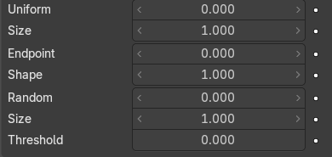
Roughness
Amount of location dependent roughness.

Size
Size of location dependent roughness.

Uniform
“Rough End” randomizes path ends (a bit like random negative clumping). Shape may be varied from <1 (parabolic) to 10.0 (hyperbolic).

Size
It is based on children location so it varies the paths in a similar way when the children are near.

Endpoint
“Rough End” randomizes path ends (a bit like random negative clumping). Shape may be varied from <1 (parabolic) to 10.0 (hyperbolic).

Shape
“Rough End” randomizes path ends (a bit like random negative clumping). Shape may be varied from <1 (parabolic) to 10.0 (hyperbolic).

Random
It is based on a random vector so it is not the same for nearby children. The threshold can be specified to apply this to only a part of children. This is useful for creating a few stray children that will not do what others do.

Size
It is based on a random vector so it is not the same for nearby children. The threshold can be specified to apply this to only a part of children. This is useful for creating a few stray children that will not do what others do.

Threshold
It is based on a random vector so it is not the same for nearby children. The threshold can be specified to apply this to only a part of children. This is useful for creating a few stray children that will not do what others do.

Children panel - Type Simple + Interpolated - Kink subpanel
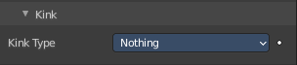
With Kink you can rotate the children around the parent.

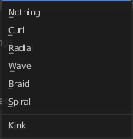
Kink Type

Nothing
Deactivated.

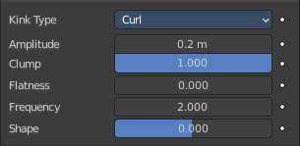
Curl, Radial, Wave, Braid
Curl - Children grow in a spiral around the parent hairs.
Radial - Children form around the parent a wave shape that passes through the parent hair.
Wave - Children form a wave, all in the same direction.
Braid - Children braid themselves around the parent hair.

Amplitude
The amplitude of the offset.

Clump
How much clump effects kink amplitude.

Flatness
How flat the hairs are.

Frequency
The frequency of the offset (1/total length). The higher the frequency the more rotations are done.

Shape
Where the rotation starts (offset of rotation).

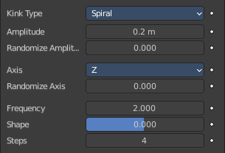
Spiral
Generates a spiral at the end of each hair.

Amplitude
The amplitude of the offset.

Randomize Amplitude
Give the amplitude a random variation.

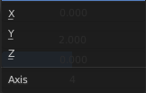
Axis
Which axis to use for offset.

Randomize Axis
Randomize the orientation.

Frequency
The frequency of the offset (1/total length). The higher the frequency the more rotations are done.

Shape
Where the rotation starts (offset of rotation).

Steps
Extra steps for resolution of special kink features.

Children panel - Type Interpolated
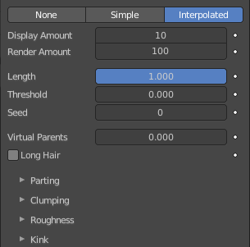
Children are emitted between the Parent particles on the faces of a mesh. They interpolate between adjacent parents. This is especially useful for fur, because you can achieve an even distribution. Some of the children can become virtual parents, which are influencing other particles nearby.

Display Amount
The number of children in the 3D Viewport.

Render Amount
The number of children to be rendered.

Length
Length of child paths.

Threshold
Amount of particles left untouched by child path length.

Seed
Offset in the random number table for child particles, to get a different randomized result.

Virtual Parents
Relative Amount of virtual parents.

Long Hair
Belongs to Hair particles. Calculate children that suit long hair well.

Children panel - Type Interpolated - Parting subpanel

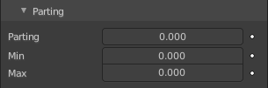
This panel belongs to Hair particles.

Parting
Creates parting in the children based on parent strands.

Min
Minimum root to tip angle. Tip distance / root distance for long hair.

Max
Maximum root to tip angle. Tip distance / root distance for long hair.

Children panel - Type Interpolated - Clumping subpanel
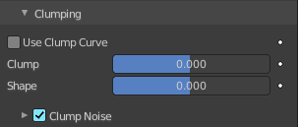
Clumping allows as the name says to break the even look, and clump particles together.

Use Clump Curve
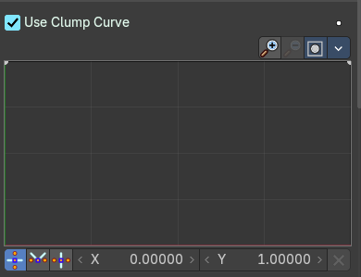
Use a Curve instead of parameters to adjust the clumping.

Adding Points
You can add new curve points by simply left clicking at the curve. Move the mouse to position them where you need it.

Selecting Points
You can select curve points by clicking at them.
Selected points can be moved around. Left click at them, hold the mouse button down and move them to a new location.

Navigation elements
The navigation elements at the top are described from left to right.

Zoom in and out
The two buttons with the magnifying glass at it zooms in and out in the curve window.

Clipping
Clipping options. Set up clipping for the stroke.

Delete Points
Deletes selected curve points.

Tools
Tools is a menu where you can find some curve related tools.

Reset View
Resets the curve windows zoom.

Extend horizontal
Extend the curve horizontally before the first and after the last curve point.

Extend vertical
Extend the curve vertically before the first and after the last curve point.

Reset Curve
Resets the curve to the initial shape.

Vector Handle
Set handle type to Vector.

Auto Handle
Set handle type to Auto.

Auto Clamped Handle
Set handle type to Auto Clamped.

X / Y values
The x and y position of the current selected curve point.

Delete Points
Delete the current selected curve point.

Clump
Clumping amount along child strands. The children may meet at their tip (1.0) or start together at their root (-1.0).

Shape
Form of Clump. Either inverse parabolic (0.99) or exponentially (-0.99).

Clump Noise subpanel
Creates random clumps around the parent hair.

Clump Noise Size
The size of clump noise.

